Rail Update | May 2023
In his latest update, policy advisor Paul Tetlaw details the current position of the railway in Scotland as well as the key Anglo-Scottish routes. He also comments on the progress being made to decarbonise the railway in light of the Government’s commitment to decarbonise by 2035.

Recovery from Covid
Covid clearly had a severe impact on the numbers choosing to travel by rail. This was not helped by government messaging that deterred people from using public transport with a consequent increase in private car use. In spite of this – and messages of doom and gloom about the period of time that passenger numbers would take to rebound – we have seen a rapid return to rail use. This varies by operator and has been impacted by prolonged periods of strike actions by the rail trade unions but there remains a clear desire to use the railways. This is most evident in the growth in leisure travel which in many cases now exceeds pre-covid levels. What is still missing is the previous high levels of business and commuter traffic and this impacts on railway finances as revenue recovery lags behind the recovery in passenger numbers.
Looking at individual rail operators LNER stands out. In April to September 2022 LNER carried 6% more passengers than the same period in 2019, despite many days of strike action and major engineering work. Evidence that leisure travel is booming is highlighted by LNER regularly seeing 50% more passengers on Sundays than pre-covid times. This is no doubt helped by their imaginative marketing of the many attractive destinations they serve – very redolent of the LNER of the 1930s. The LNER East Coast route from Edinburgh to London currently enjoys a greater than 50% modal share compared to air: up from 35% pre-covid. However this is now threatened by recent UK Government policy decisions (more on this in a later section).
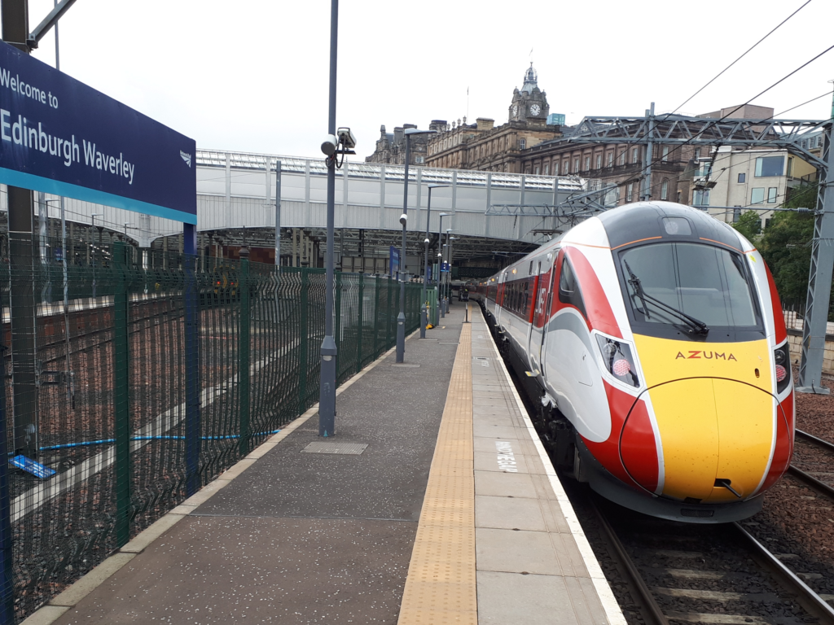
Credit: Paul Tetlaw
On the West Coast route from Glasgow to London Avanti has 40% of the market compared to air’s 60% share. Passenger numbers on Avanti are 74% of pre-covid levels with revenue lagging behind at only 66% of the pre-covid figure. This is hardly surprising given the prolonged periods of industrial action by the trade unions. This does however serve to highlight the dangers of relying on staff overtime to run a 7 day a week railway. Avanti have now embarked on a major driver recruitment campaign and it is refreshing to hear that over 1500 women have applied.
On ScotRail, total journeys are currently 80% of the equivalent in 2019/20. Peak/commuter demand is at 63% whereas off-peak demand is 102% again emphasising the increased demand for leisure travel. New advertising campaigns are starting to attract passengers back to Scotland’s Railway and Saturday is now the busiest day of the week, the new May timetable sees Saturday frequency on the main Edinburgh to Glasgow route via Falkirk High increased to every 15 minutes. We are fortunate to have a railway that connects all Scotland’s cities as well as world famed rural routes such as the West Highland lines. There are many attractive destinations to promote and so continue to build passenger numbers.

Fares and ticketing
Following an announcement earlier in the year that peak fares were to be abolished for a six month trial period on the ScotRail network there followed a period of confusion as to when this might start and which routes would be covered. It has now been confirmed that this will start in October and will apply to all routes in Scotland. This is a great opportunity to promote rail services and achieve real modal shift from the car to the train. We look forward to seeing an extensive marketing programme to raise public awareness.
Elsewhere on the railway, LNER is launching single leg ticketing across the whole route from 11 June. This removes the anomaly of some single tickets being almost the same price as a return ticket and so passengers can choose the best ticket that is available for their journey at the times they choose to travel.

New lines and stations
The Levenmouth line is scheduled to open in 2024, the two new stations added to the network will be those at Levenmouth itself and Cameron Bridge. Inverness Airport station opened on 3 February – how much patronage it receives from air passengers remains to be seen as it is some considerable walking distance from the current airport terminal and there is a direct bus from the terminal to Inverness. Looking further ahead, there are plans for housing development in the area and this may well lead to significantly increased patronage at the station.
On the East Coast Main Line (ECML), East Linton station is progressing well and will be the second new station to open between Edinburgh and Berwick-upon-Tweed, following that at Reston. We understand that it is planned to serve the station by seven Transpennine Express (TPE) and five ScotRail trains daily. It is to be very much hoped that the industrial relations problems at TPE are resolved by the time that the station opens as Reston has suffered from a very unreliable service from TPE since opening.
The recent announcement that TPE will transfer from First Group ownership to the DfT’s OLR Holdings Ltd (DOHL) is not unexpected and this means that they join LNER, Northern and Southeastern in UK Government ownership. How the trade unions react to this change remains to be seen but we must hope for significant improvements in performance by the operator. It is however noteworthy that in the case of LNER we are fortunate to be served by one of the leading UK rail operators.

Freight
The Transport Scotland approach of encouraging growth of rail freight is to be welcomed as on average one freight train removes 76 HGVs from the road and so greatly assists with the decarbonisation agenda.
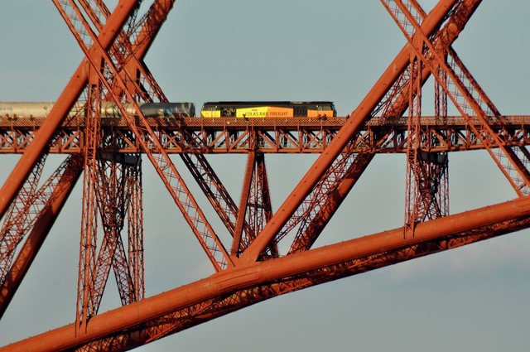
Credit: Colas Rail
Recent good news on this front is the Highland Spring rail service introduced last autumn. However, for significant growth in rail freight we need more capacity on the rail network in Scotland and on Anglo-Scottish routes.

Caledonian Sleeper
From 25th June 2023 the Caledonian Sleeper services will be run by an arm’s length company owned by the Scottish Government – as opposed to being run by Serco who have operated the service since the last franchise award. They thus follow ScotRail into Government ownership. Sleeper services to Scotland recently celebrated 150 years of operation since the North British Railway first introduced a sleeper carriage on the ECML. So, as with LNER, there exists a proud history to record and great potential to grow services and passenger numbers to and from Scotland.

Progress with decarbonisation
The Decarbonisation Action Plan (DAP) for rail services was published by Transport Scotland in May 2020. It is very detailed and sets out how the passenger railway will be decarbonised by 2035, this includes extensive electrification coupled with orders for new trains and we were happy to welcome this plan at the time.
The new train orders are in three tranches:
- Urban Battery Multiple Units (BEMUs) plus replacements for the oldest electric trains operating in the West of Scotland area.
- New inter-city trains to replace the current 125s.
- New trains for the rural routes which have been characterised as likely to be battery or hydrogen operated.
The end date is now only 12 years away and progress to date is slow. At the Cross Party Sustainable Transport (CPG) meeting at the Parliament on 10 May David Clarke of the Railway Industry Association stated that we now need to electrify at a rate of 120 single track kilometres (stk) for the next 12 years. He was keen to emphasise that a continual work programme is the most efficient way to accomplish this as it will help to retain skilled staff and bring down unit costs. A stop/start approach leads to the opposite outcome.
The current slow rate of progress is characterised by only the Barrhead and East Kilbride lines being approved for electrification with passive provision being provided on the Levenmouth line. There is an urgent need to start work on the partial electrification of the Borders and Fife lines coupled with placing orders for new BEMUs to run on these lines. However, none of this has been approved and we understand that a review of the DAP is to be published this year. One hopefully positive sign is the £160m investment committed to upgrading electric supplies across the routes to be electrified; this was confirmed by Lee Pounder of SPL Powerlines at the CPG on 10 May.

UK Government policies
As mentioned earlier there has been a welcome modal shift from air to rail on Anglo-Scottish routes. However, recent policy decisions by the UK government appear totally at odds with supposed commitments to net-zero targets and the consequent need to achieve modal shift to more sustainable forms of transport. The decision to reduce air passenger duty on domestic flights from 1 April will surely encourage a shift from rail to air on the key Central Scotland to London routes and yet bizarrely a UK government policy paper on the subject published on 15 March claims that “this measure… aligns Air Passenger Duty more closely with the government’s environmental objectives”.
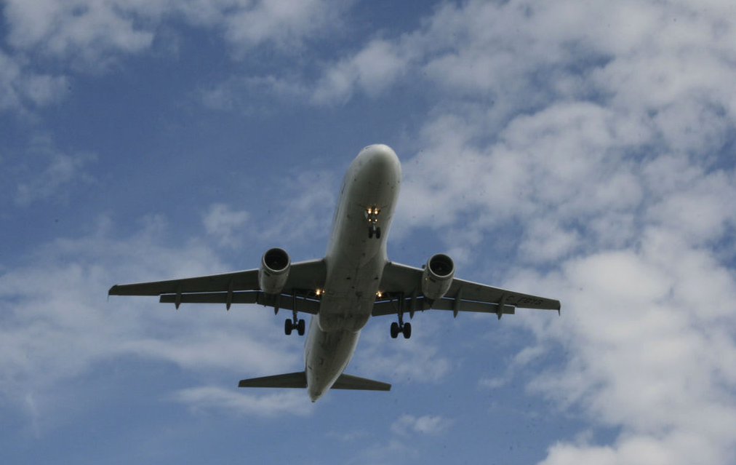
Credit: Richard Eriksson
What is clearly required is more capacity on both the ECML and WCML to introduce extra passenger and freight services and speed-up key inter-city services. One of the ways to help achieve these objectives is the HS2 project and yet that is now suffering from severe cutbacks and is currently set to be little more than a new line from Birmingham to the outskirts of London at Old Oak Common.

Great British Railways
This new body to oversee the railways in the UK is to be based in Derby. It will absorb Network Rail and take on its responsibilities, whilst also overseeing train services. Parliamentary time at Westminster for the necessary legislation is still awaited but it may formally come into being in autumn 2024. Assuming this doesn’t happen before the next general election and assuming Labour form the next government it does not appear to be top of their priority list. So Great British Railways remains surrounded in uncertainty. How the new body will impact on the railway in Scotland remains to be seen but with the Scottish Government having devolved powers over the ScotRail and Caledonian Sleeper franchises it seems likely that we’ll see little change.

